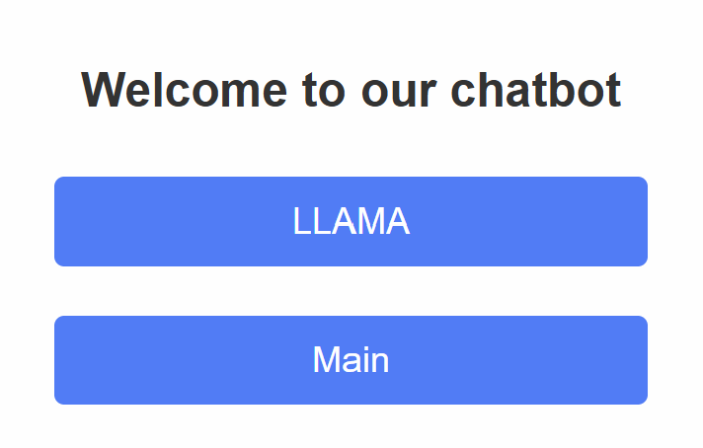

Please add one button in addition to LLAMA, eg Deepseek or Sealion

